

Dr. Christopher, Wagner inc.

2015-02-09

Dr. Wagner

4301 Anthony Center, New Erika, IA 00525

Phone: 929601965

Fax: 4669672490

**Re:** Kathleen, Fox

**PHN:** 2045906504

**Birthdate:** 13-Sep-1987

**Address:** 3352 Hudson Club, Donnaton, FL 50769

**Patient number:** 9223436534

To Whom It May Concern:

This is a medical letter to state the above patient is pregnant with expected delivery date of 25-Aug-2025. Hoping this information is satisfactory for your requirements.

Thank you.

Sincerely,

Dr. Christopher, Wagner

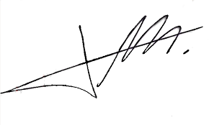

FRCS© NCMP

Clinical Assistant Professor, UBC

Department of Obstetrics and Gynecology SMH